CCS4065 Software Test Report.

Performing the software test

* First and foremost, do your best to help your classmates improve their project, and keep in mind that you are also being evaluated on this assignment. Students who have clearly spent time considering and carefully evaluating their test site, and who have given detailed, thorough, and thoughtful feedback in their review, will receive the best grades for this assignment.
* This is an individual assignment. Do not do it as a group; this way the group being tested will get the best feedback.
* There are two parts to the test; first, register as an individual, i.e. someone seeking employment, and test the functionality available for these sorts of users. Second, register as a company, and then test the functionality available for them.
* If some functionality is not available, note that in your answers below.
* Back everything up with examples. For example, if you try something that appears to cause the site to crash, give as much information as possible to help the other group fix the problem.
* Do not give one word answers.
* The group that you are testing are **not being graded**. This means that if you spot a problem in their site they will not be penalized by the teaching team; the point of this exercise is to help them find problems before the final demo, so please point out any problems you find, regardless of how minor they seem.

Student Name: David Beck

Student ID number: 8308055

Student Group Number: Group03

Group being tested: Group05

Date of test: 20/07/2018

1. Was there an index.html file? Was it obvious what the website was from the first page?
   * There was an index.php page.
   * The background on the login page was of a group of young people socializing and this along with the message on the login dialog gave a good indication that this was a dating website.
2. What is the site for? Describe the industry that the site targets.

* The site is for a dating website to allow users to find other users with characteristics similar to their own or to search for users with characteristics that they find attractive.

1. How well did the individual registration section work? What happened when you put in malformed input (for example, mismatched passwords, wrong types, etc.)?
   * I registered with my UL email address and a valid password and I was brought to a Personal Details page.

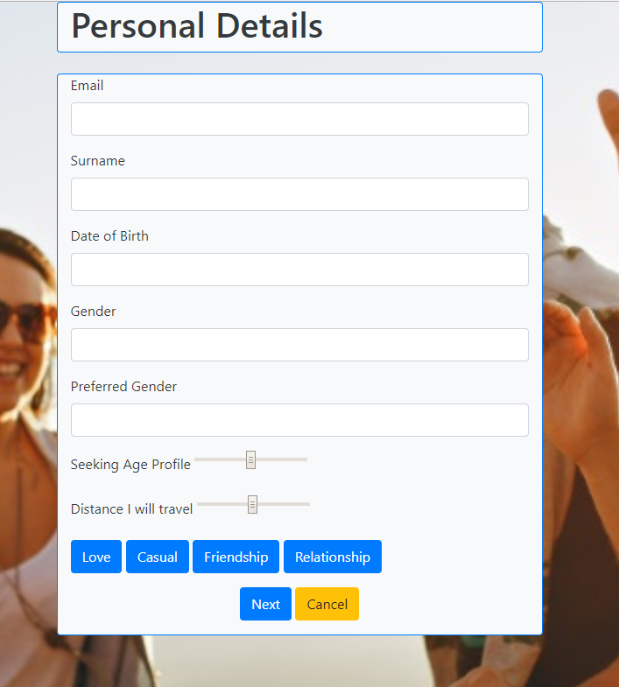

* + This page asked me for my email address again when I had just entered it on the previous page.
  + Only the Surname is requested which is not particularly friendly.
  + Date of Birth, Gender and Preferred Gender are all open text entry fields where date picker and dropdown lists would be more appropriate.
  + The Seeking Age Profile and Distance I will travel controls give no indication what the actual values are.
  + The Seeking Age Profile should be a range instead of a single value.
  + It is hard to know how the Distance I Will Travel requirement will work as it would need to calculate the distance between the two users’ locations. This is difficult normally but it would be even harder not having the locations.
  + Clicking any of the Relationship Type buttons on this form clears all entry fields. A Radio Button control may have been a better option here.
  + Clicking Next brings you to the Personal Details 2 page without any validation

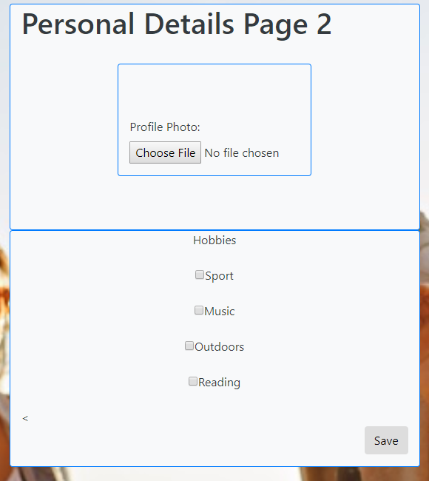

* + This page allows for the Profile Photo to be uploaded and details to be saved. The File control allows a file to be selected but it is difficult to know if it was uploaded successfully. Checking on the server I do not have access to the images folder so I am unable to check if the file was uploaded but I suspect not.
  + After clicking Save all fields are cleared but I remain on the same page and have no indication if my details have been saved.
  + There is no prompt on the page where to go next and there are no links to the home page or even back to the login page.
  + I went back to the login page manually and was able to login with the account I just created so the profile was created.
  + On the login page, both user and password validation worked and I was only allowed to login with valid details.
  + On the Register page only valid email addresses are accepted and I was unable to create a new profile with the same email address as previously.

1. Did the search function work?
   * I logged in with the [lisa.sharp@gmail.com](mailto:lisa.sharp@gmail.com) profile and went to the Search (Find Match) page.

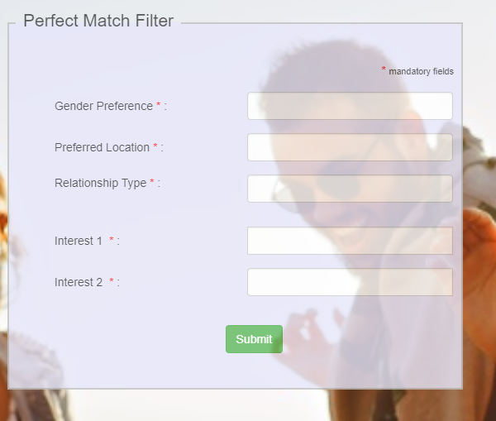

* + All fields on the form are mandatory which makes it very difficult to do a general search.
  + There is no indication of the type of entry required. For example, it is difficult to know what is acceptable in the Gender and Relationship Type fields.
  + Location was not entered on the User Profile page so it is difficult to know how this will work.
  + On the profile page Interests were entered as checkboxes. This would be a better option here as it is difficult to know what to enter in these fields also.
  + I entered all the mandatory fields on the form and clicked Search but nothing happened. It appears that the Search function is not complete.
  + Clicking the About button on the navbar logged me out of the site.
  + I used the back button in the browser to go back to the Search page but when I went from there to the Meeting Space page all Match details were missing so it looks like the User Id was lost.
  + Clicking Logout gave me a Page Not Found error for logout.php.
  + Clicking Home brought me back to the Meeting Space home page.

1. What was the “look and feel” of the site like? Was it pleasant to use or were there rendering problems and/or missing links?

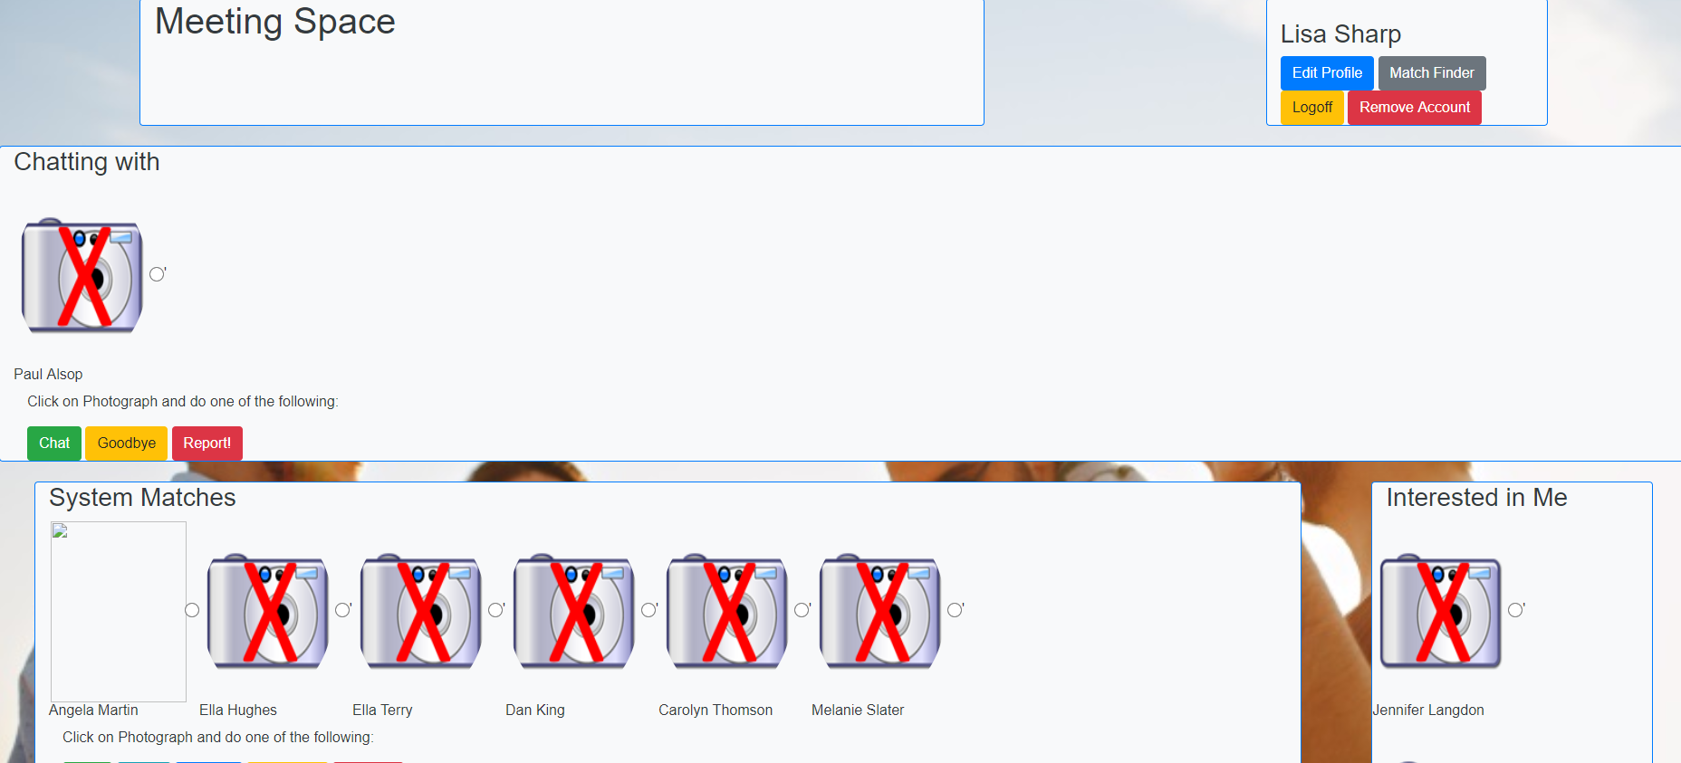

* + The home page of the site “Meeting Space” is a good idea but does not look great. Each section of the page is a different shape and size. Some sections scroll horizontally and others vertically.
  + This page should have a navbar which could have a menu for Edit Profile, Match Finder, Logoff and Remove Account. The buttons that are there currently are very clunky.
  + Without actual images it is difficult to get a good sense of how the page will look and work.
  + Having to click the image and then click one of the buttons below is not a great experience. It would be better if clicking the image opened a details page of the other users where you could select the option you wanted.
  + Clicking the View button on an image brough up a ViewMatchProfile page.

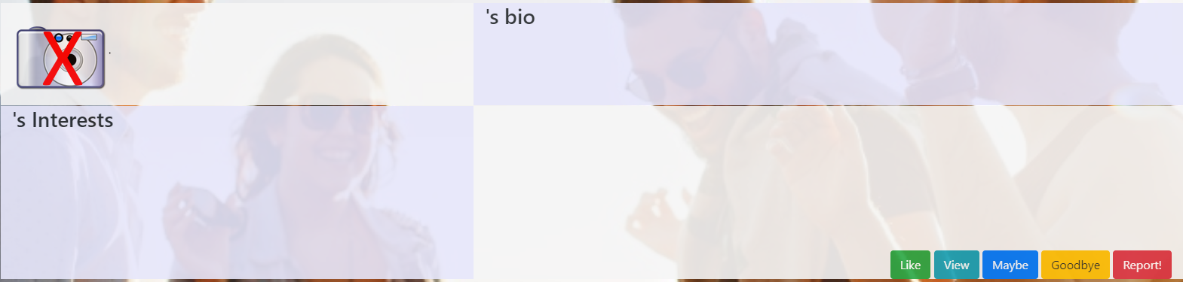

* + This page is empty currently so it is difficult to know how it will look when finished.
  + It has the same set of options as the previous page. View is not appropriate here as you are already viewing the user’s profile.

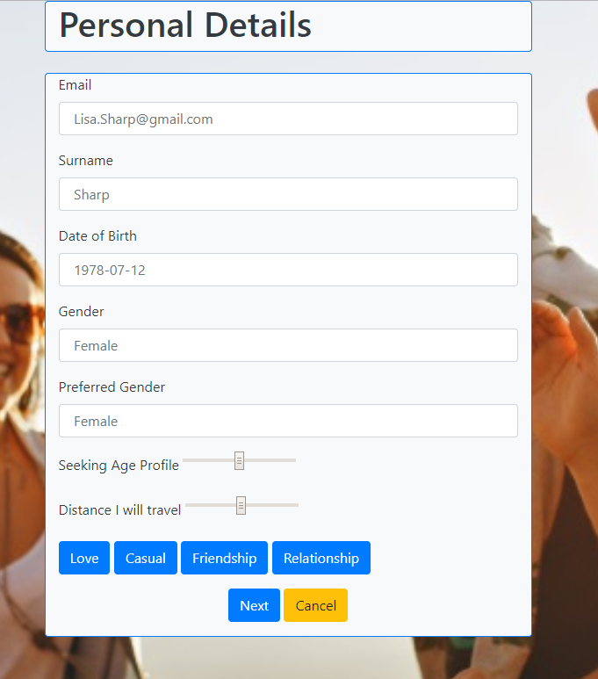

* + This is the Edit Profile page. Again it is divided into 2 pages.
  + When loaded the page contains the details of the user but none of the details can be edited.
  + Clicking Next takes you to the second part of Edit Details.

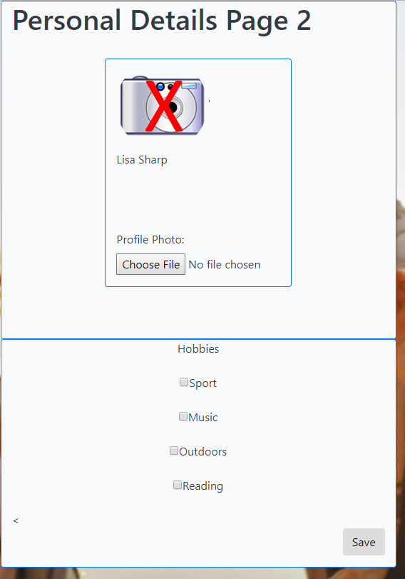

* + Even though you already have a picture saved, you are still required to pick another picture. Clicking Save does not appear to save any changes to the profile.
  + There is a left chevron on the page which appears to be a link back to the previous page but it doesn’t do anything.

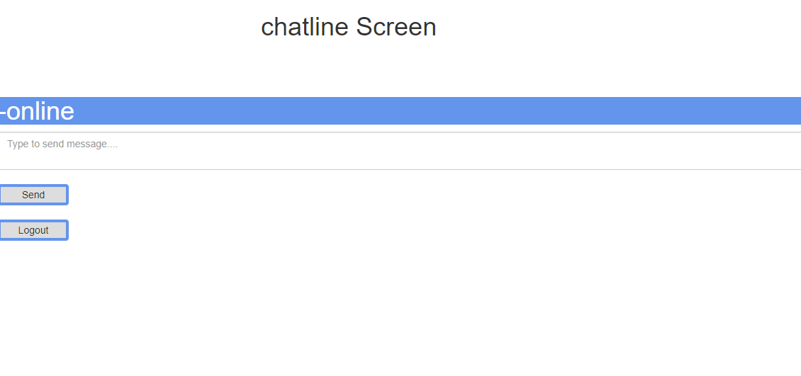

* + This is the Chat page but it does not appear to have any functionality yet.
  + The style is completely different to the rest of the site so it looks like you are on a completely different website, particularly as there is a Logout button on the actual page.
  + There doesn’t appear to be any way of seeing messages sent from the other user.
  + There is no indication of who the other user is that you are chatting with.

1. Do you have any additional suggestions or advice for your classmates? If so, please make them here.
   * Get greater consistency across the site. All pages should look similar with links to make it easier to navigate.
   * Put the navbar on every page with useful links presented in a menu format.
   * The different sections on the Meeting Space page are very clunky. Get more consistency in each section.
   * Remove the action buttons from each section of the Meeting Space page. When a user clicks on an image open a new page with the details of the user just clicked on and have the actions on this page.
   * Put all the user profile related fields on one page and the preference fields on another.